1. **Agenda**:
   1. Docker Compose.
2. **Requirement**:
   1. You have 50 microservices.
   2. You need to issue docker run command 50 times.
   3. It is not feasible solution.
   4. **Solution**: Docker Compose. A tool that was developed to help define and share multiple container applications.  
      Like with docker compose, we can create a YAML file to define all the services that you want to create with a single command.  
      So, with a single docker compose file and single command, you can spin everything up or stop everything down with a single command.  
      The big advantage of using Docker Compose is you can define your app stack in a single file and keeping it at the root of your project repo, you can make all of your services up and running with just one command.  
      You must have docker composed installed.
3. Let’s write a Docker Compose File which contains all the docker image details from where containers have to be created.
4. 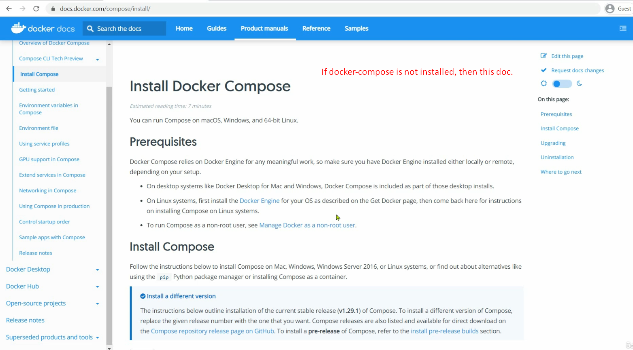
5. 
6. 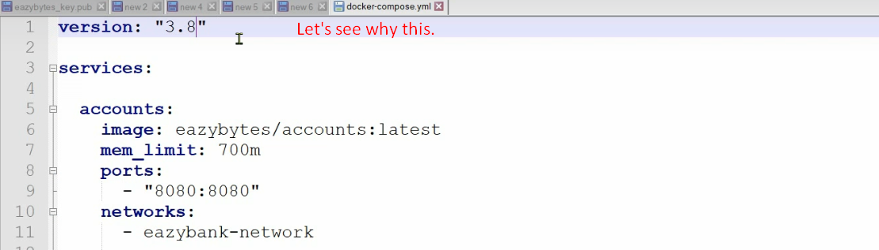
7. 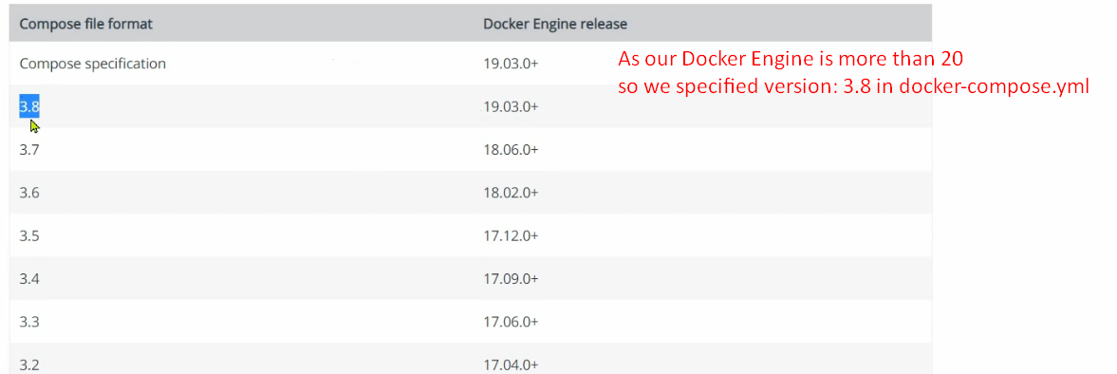  
   **NOTE**: Above version Docker Engine not of Docker Compose. So, run command 🡺 docker –version not docker-compose –version.
9. 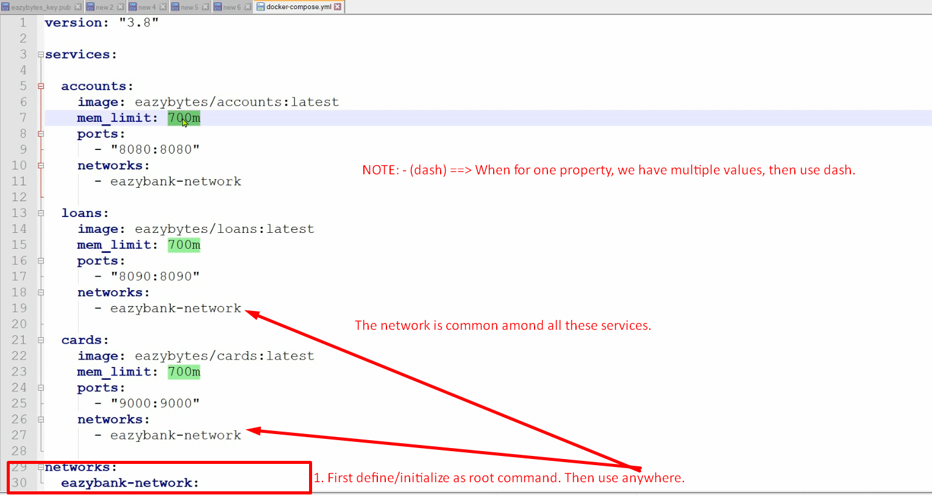  
   **mem_limit**: Defining the max memory limit for a service.
10. 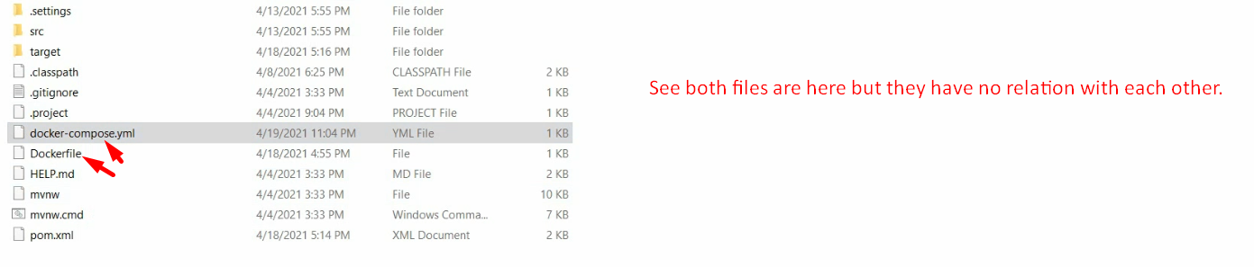  
    **NOTE**: docker-compose.yml file can be placed anywhere on your system as it doesn’t need source code of your project but the images.
11. Allowed file names and extensions:  
    
12. 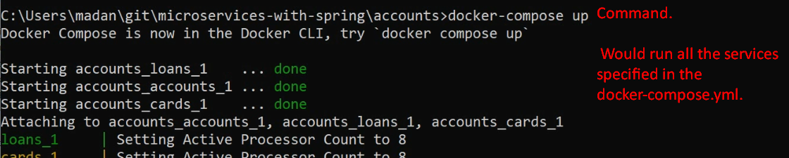
13. 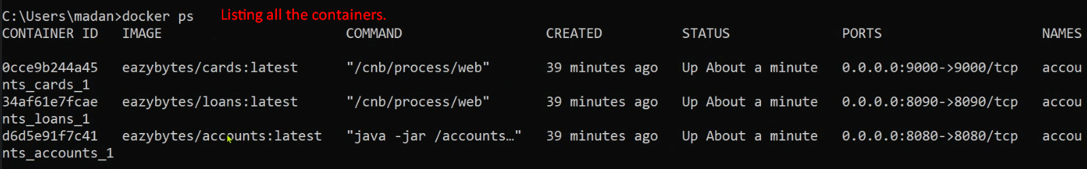
14. 